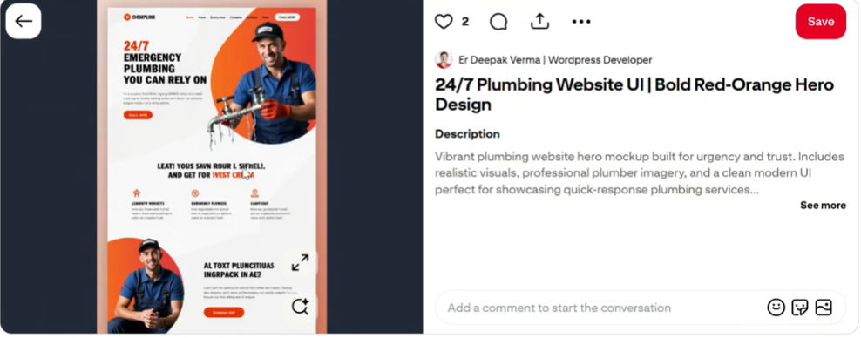

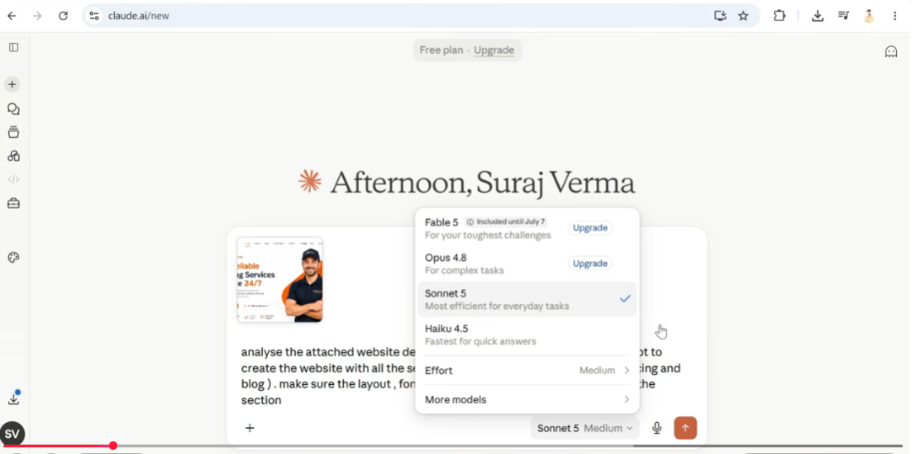
Prompt text

analyse the attached website design mockup and give me a detailed prompt to create the website with all the sections mentioned in menu except (financing and blog). make sure the layout, font, color and vibe remains the same for all the section
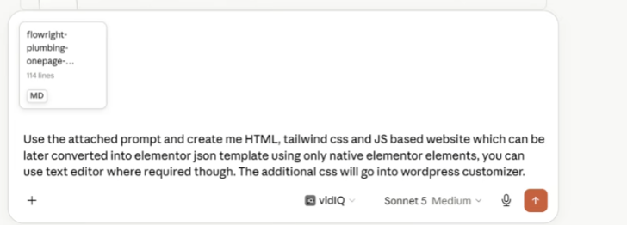
Prompt text
Use the attached prompt and create me HTML, tailwind css and JS based website which can be later converted into elementor json template using only native elementor elements, you can use text editor where required though. The additional css will go into wordpress customizer.
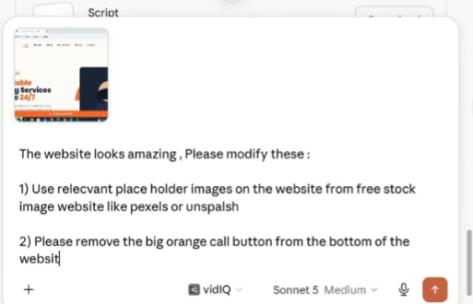

Prompt text
The website looks amazing, Please modify these:
1) Use relecvant place holder images on the website from free stock image website like pexels or unspalsh
2) Please remove the big orange call button from the bottom of the website

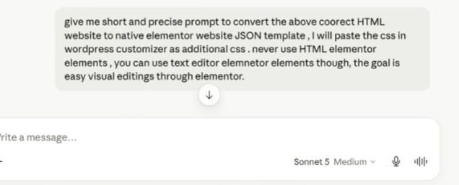
Prompt text

give me short and precise prompt to convert the above coorect HTML website to native elementor website JSON template, I will paste the css in wordpress customizer as additional css. never use HTML elementor elements, you can use text editor elemnetor elements though, the goal is easy visual editings through elementor.

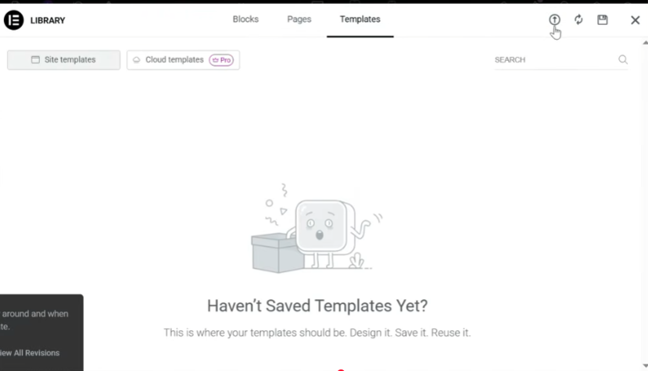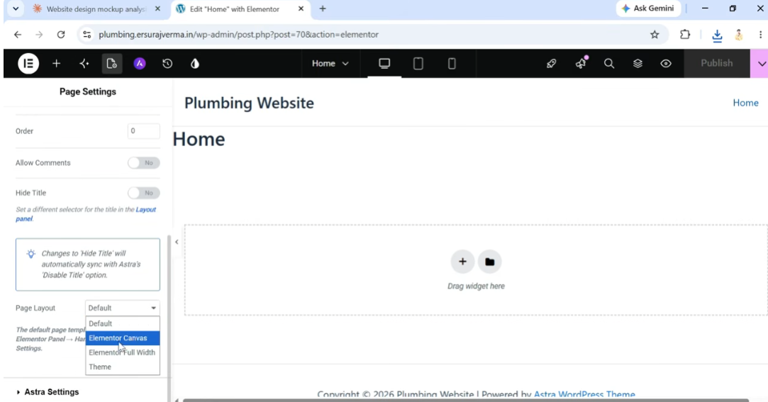

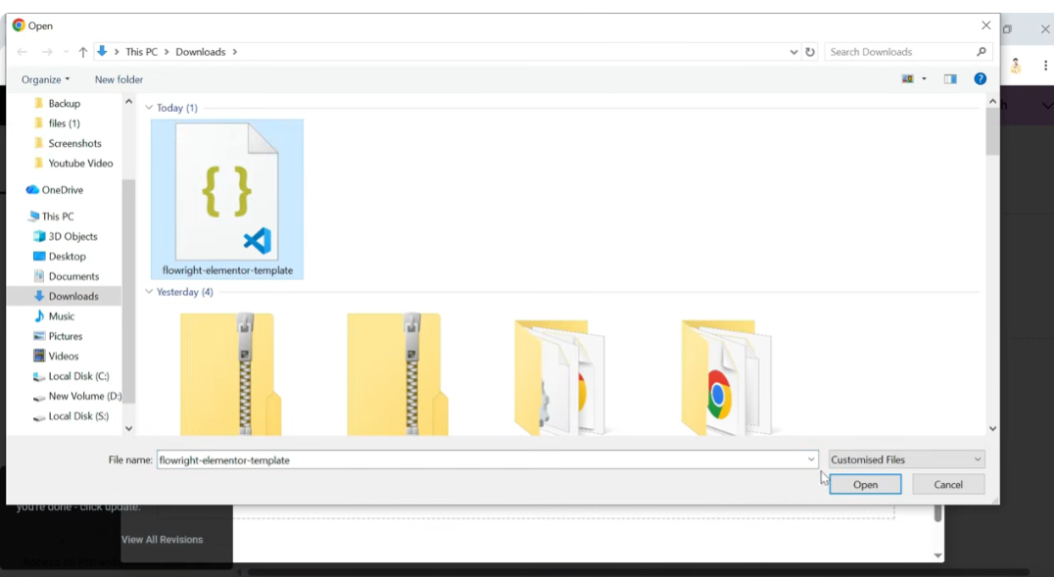

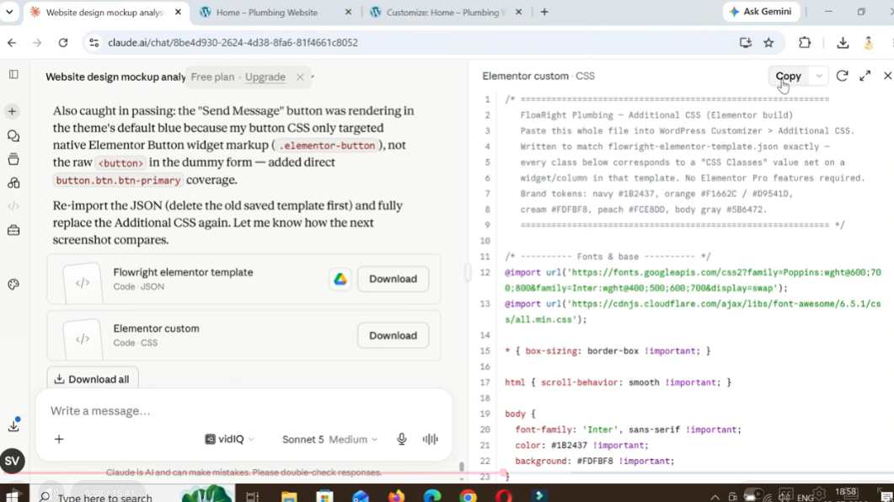

Css Elementer
